Role Profile



Corporate Partnerships Manager



JOB Role:
JOB TITLE: | Corporate Partnerships Manager | SALARY: | £34,000 - £38,000
REPORTING TO: | Head of Fundraising and Communications | HOLIDAYS: | 33 days including bank holidays and an extra day off on your birthday.
LOCATION: | Future Youth Zone, 201-225 Porters Avenue, Dagenham, RM9 5YX | HOURS: | Permanent: full-time, 40 hours per week. (hybrid working available).
THE PERSON: | We are seeking an experienced fundraiser, business development, and partnerships manager to drive forwards our corporate partnerships. You will have excellent organisation, communication and interpersonal skills, and be confident building relationships with a range of individuals from local, regional and national companies.  At Future we are one team, and this is an opportunity to be fully involved in the organisation, working directly with front line staff and young people to bring in income for our core work and projects.
KEY RELATIONSHIPS: | Senior management, trustees, fundraising and communications team, delivery team, young people, existing corporate patrons and potential corporate donors, OnSide network

Future Youth Zone was founded 6 years ago on a solid foundation of corporate and philanthropic patron support, each giving at least £25k per annum and with a multiyear commitment. Our fundraising team with the support of Trustees and senior leaders have forged strong relationships with our founding patrons which means that many still donate generously today. Over the last 3 years we have been working on diversifying our income streams to ensure that the charity is sustainable for the long term with significant success in statutory funding and grants and trusts fundraising.

This is a unique opportunity to work alongside Future’s Head of Fundraising & Communications and the wider fundraising team to create a strong corporate fundraising programme that will develop multi-year partnerships with businesses in East London and beyond. The successful candidate will provide outstanding account management to those who have already given as well as inspiring companies who have a connection with young people in East London to join our family of funders.
This role presents a great opportunity for a creative and self-motivated corporate fundraising specialist, who has a proven track record of success in this field. The successful candidate will be an expert in account management development with corporate partners. A pre-requisite for this role will be experience of raising significant funds from new business opportunities.

CONTEXT OF THE POST:
Barking and Dagenham Youth Zone, named as Future by young people, was opened in May 2019. The Youth Zone is an independent Charity, but we are proud to be part of the growing OnSide Network whereby we have adopted a set of principles that guide our work with young people.
Our universal offer is focussed around a state-of-the-art, multimillion pound facility that is purpose built and remains dedicated to young people. We work with young people aged from 8-19 (up to 25 with additional needs) and offer an array of activities for young people to get involved in. Our services are affordable for young people who can access the provision for just a £5 annual membership and 50p entry fee. Whilst our building and activities provide a hook for young people to initially engage with us, the relationships they develop with our team of Youth Workers ensures they return night after night. We pride ourselves on being open when young people need us the most, during evenings and weekends, whenever schools are closed.

Since we opened in May 2019 the Youth Zone has had over 12,000 young people sign up as members of which around 60% are male and 40% are female. At times during our opening year 1,600 young people were visiting the Youth Zone every week, making it a go to destination for the next generation. From March 2020 through to January 2022 the Youth Zone operated under a variety of restrictions and challenges because of the Covid-19 pandemic. During that period, we were able to continue to support young people using new and innovative forms of engagement, whilst we also extended our support to the wider community when they needed it the most.

More recently we have been able to return to a full universal offer for young people and despite the prevalent challenges around the lasting impact of the pandemic, young people feeling isolated and the cost of living crisis our team continue to provide a home from home for young people.

DUTIES AND RESPONSIBILITIES – DETAILED

- To play a leading role in delivering Future’s Corporate and Events Fundraising strategies, building long term income streams that can grow year on year.
- Build connection with the amazingly generous individuals who support Future Youth Zone, bringing to life the impact of their support through creative communications, reports and events. Work to and create stewardship plans for all corporate supporters, bespoke to their needs. Through this, ensure donation pledges are met and where possible, renewed.
- Develop a pipeline of potential donors, through exploring Future’s networks, individuals with connections to Barking & Dagenham or an interest in supporting young people to reach their potential.
- Lead and support Corporate Volunteering programmes and events.
- Provide excellent stewardship of all current relationships including marketing and fundraising initiatives throughout the year.
- Lead on Future’s annual Golf Day, to be held in May 2025, with support of the team, aiming to raise £25k+.
- Work with Fundraisers at other London Youth Zones to develop partnerships with companies who can support multiple Youth Zones.
- Evaluating events and keeping up to date with the events and corporate fundraising sectors, to appropriately plan future activity.

DUTIES AND RESPONSIBILITIES - GENERAL
- Be a role model for young people and present a positive “can do” attitude.
- Take personal responsibility for own actions.
- Commit to a culture of continuous improvement.
- Work within the performance framework of Future Youth Zone and OnSide.
- Represent Future Youth Zone positively and effectively in all dealings with internal colleagues, and external partners.
- To be alert to issues of safeguarding and child protection, ensuring the welfare and safety of Youth Zone members is promoted and safeguarded, and to report any child protection concerns to the designated Child Protection Officers using the safeguarding policies, procedures and practice (training to be provided).
- To assist with any promotional activities and visits that take place at the Youth Zone.
- To always adhere to Future Youth Zone policies, with particular reference to Health and Safety, Safeguarding and Equal Opportunities.

PERSON SPECIFICATION

Selection Criteria*  A = Application Form I = Interview T = Test/Personality Profile | Essential or Desirable | Method of Assessment
Experience
Experience of successfully winning 4 or 5 figure charitable donations | Essential | A & I
Experience of local business/charity sector | Desirable | A & I
2 years minimum fundraising experience | Essential | A & I
Supporting junior colleagues or line management | Desirable | A & I
Experience organising fundraising, or other professional events | Desirable | A & I
Qualifications
Educated to Degree level in a relevant subject or equivalent experience | Desirable | A
Skills
Excellent relationship building and interpersonal skills | Essential | A & I
Excellent written communication skills | Essential | A
Able to work as part of a team and under own initiative | Essential | A & I
Excellent organisational skills | Essential | A & I
Confident with budgets | Desirable | A & I
Able to work flexibly and under own initiative to ensure deadlines are met and tasks are prioritised | Essential | I
Able to communicate with a range of stakeholders | Essential | I
Knowledge
Understanding fundraising landscape | Essential | A & I
Understanding of issues facing young people and youth work | Desirable | A & I
Special Requirements
Passion for raising money for a charity working with children and young people | Essential | A & I
The willingness to be part of a wider team and understand the core Youth Zone delivery model. | Essential | A & I
Enhanced DBS clearance and commitment to Safeguarding children | Essential | A & I
A willingness to work unsociable hours when required | Essential | A & I

THE OTHER BITS…

Future Youth Zone is committed to the safeguarding of young people. In accordance with our Child Protection and Safeguarding procedures, this position requires an enhanced DBS check.

The strength of OnSide Youth Zones comes from the diversity of the people within our vibrant network. We are proud that our Youth Zone teams reflect the communities they serve, and we value people working together from a range of different backgrounds locally and nationally, and with different experiences, all with a shared passion for boosting the aspirations of young people across the country. Diversity brings innovation, fresh ideas and creativity, and we actively strive to create a culture that is truly inclusive and fair for all and where everyone in the team can be themselves and thrive.

For information regarding how Future Youth Zone and OnSide Youth Zones process your data, please visit www.futureyouthzone.org/privacy-policy/

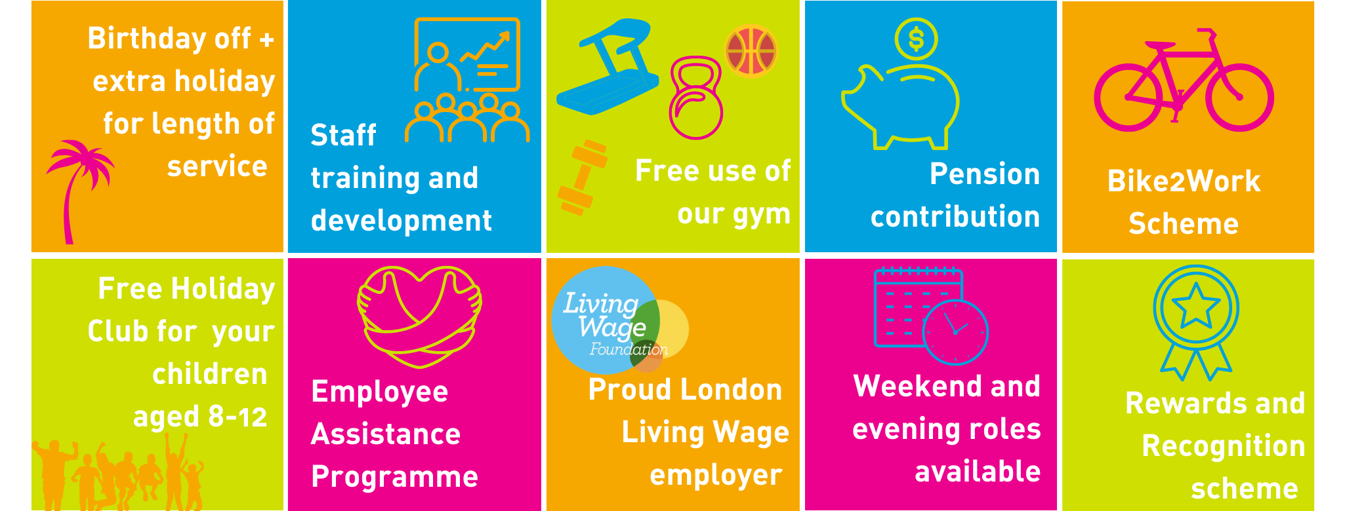
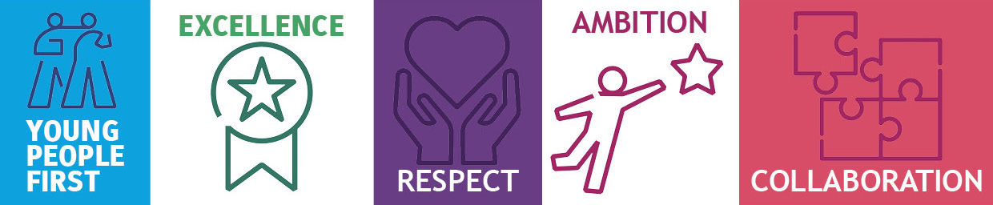
OUR VALUES AND STAFF BENEFITS:

